Assignment 3

**Q.1 Give examples of when you would prepare rough order of magnitude (ROM), budgetary, and definitive cost estimates for an information technology project (please make an assumption or use one example provided in Week7/Chapter7). Give an example of using each of the following techniques for creating a cost estimate: analogous, parametric, and bottom-up. (1 mark)**

The rough order of magnitude would be prepared in the very start of the project or even

before a project is officially started. As the name suggest, it is a rough estimate of what

the project is going to cost. The time frame for this type of estimate is often three or more

years prior to project completion. Ex: A rough order of magnitude estimate for providing

new iPads to 100 students might be $100000.

A budgetary estimate is used to allocate money into an organization’s budget. Many

organizations develop budgets at least two years into the future. Ex: A budgetary estimate

would break down the estimate to include hardware and software with detailed

assumptions.

A definitive estimate provides an accurate estimate of project costs. A definitive estimate

would be much more detailed and accurate than a rough estimate or budget estimate and

would include vendor quotes. For example, the actual cost for a project with a definitive

estimate of $100,000 could range from $95,000 to $110,000.

Analogous estimates, also called top-down estimates, use the actual cost of a previous,

similar project as the basis for estimating the cost of the current project. Using the above

example, we could research a similar project and estimate the costs, or we can contact the

The rough order of magnitude would be prepared in the very start of the project or even before a project is officially started. As name suggest, its rough estimate of what the project is going to cost. The time frame for this type of estimate is of 3 or 4 years prior to production. Ex. A rough order estimate of new Mack books might be $100000.

A budgetary estimate is used to allocate money into organizations budget. Many companies develop budgets at least two years into the future. Ex. A budgetary estimate would break down the estimate to include hardware and software with detailed assumptions.

A definitive estimate provides an accurate estimate of project costs. It would be more detailed and accurate than the rough estimate or budget estimate and would include supplier’s quotes. Ex. The actual cost of project with a definitive estimate of $100000 could be between $95 to $110k.

Analogous estimates are also called top down estimate, use the actual cost of previous similar project as the basis of estimating the cost of current project. Using the above example, we could research a similar project and estimate the costs. or we may contact the company to who are buying the MacBook’s.

Parametric estimating is the mathematical model to estimate costs. Here we decide main factors.

Bottom up estimates involves estimating individual work items and activities ad summing them into project total. Here we sum up all requirements such as hardware software training testing and maintenances.

**Q.2 What are the three main outcomes of quality control? Briefly describe each.**

Quality control is the process of monitoring and recording results of executing the quality activities to assess performance and recommend necessary changes. This detailed set of technical activities tests whether specific project deliverables meet their quality standards. Quality control may include inspection of inputs, activities, and deliverables. It includes a reporting system. Outputs of quality control are recommendations that may include the following:

The main 3 outcomes of the quality control are

* Acceptance Decisions: determine if products or services produced as part of project will be accepted or rejected.
* Rework: is action taken to bring rejected items into compliance with product requirements.
* Process Adjustments: correct or prevent further quality problems based on quality control measurements

**Q.3 Describe the relationship between Six Sigma and statistics**

An important concept in Six Sigma is improving quality by reducing variation. The term sigma means standard deviation. Standard deviation measures how much variation exists in a distribution of data. A small standard deviation means that data clusters closely around the middle of a distribution and there is little variability among the data. A large standard deviation means that data is spread around the middle of the distribution and there is relatively greater variability.

The rule is:

* 68% of the data points will fall within ± one standard deviation from the mean,
* 95% of the observations will fall within ± two standard deviations from the mean
* 99.73% of the data points will fall within ± three standard deviations from the mean.

Now, for Six Sigma statistics the extension would be as follows:

* 99.9937% of the data points will fall within ± four standard deviations from the mean
* 99.99994% of the data points will fall within ± five standard deviations from the mean
* 99.9999998% of the data points fall within ± six standard deviations from the mean

according to Six Sigma statistics, in a Six Sigma project, 99.9999998% of the results must fall within ± six standard deviations from the mean. In other words, only 0.0000002% of the results can be outside of the expected results

**Q.4 Create a Pareto chart based on the information in the following table. First, create a spreadsheet in Excel using the data in the table. List the most frequent customer problems first. Use the Excel template called pareto_chart.xls on the text’s Companion website and check your entries so your resulting chart looks similar to the one shown in the class. If you need assistance creating the chart, search for videos describing how to create Pareto charts using Excel. (3 marks)**

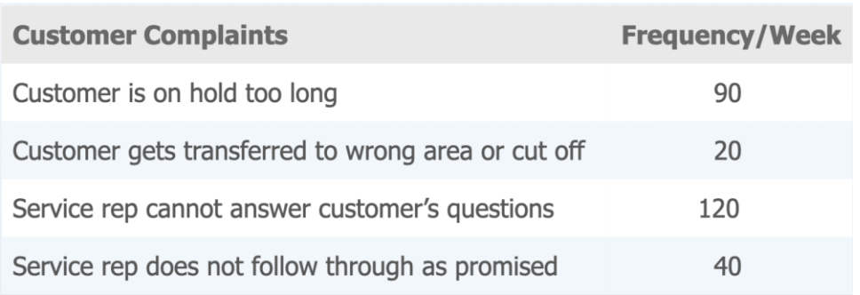

Answer:

|  |  |  |  |
| --- | --- | --- | --- |
| Customer Complaints | Frequency / Week | % of Total Complaints | Cumulative % |
| The service rep cannot answer customer's questions | 120 | 44% | 44% |
| The customer is on hold too long | 90 | 33% | 78% |
| The service rep does not follow through as promised | 40 | 15% | 93% |
| The customer gets transferred to the wrong area or cut off | 20 | 7% | 100% |
| **Total** | **270** | **100%** |  |

